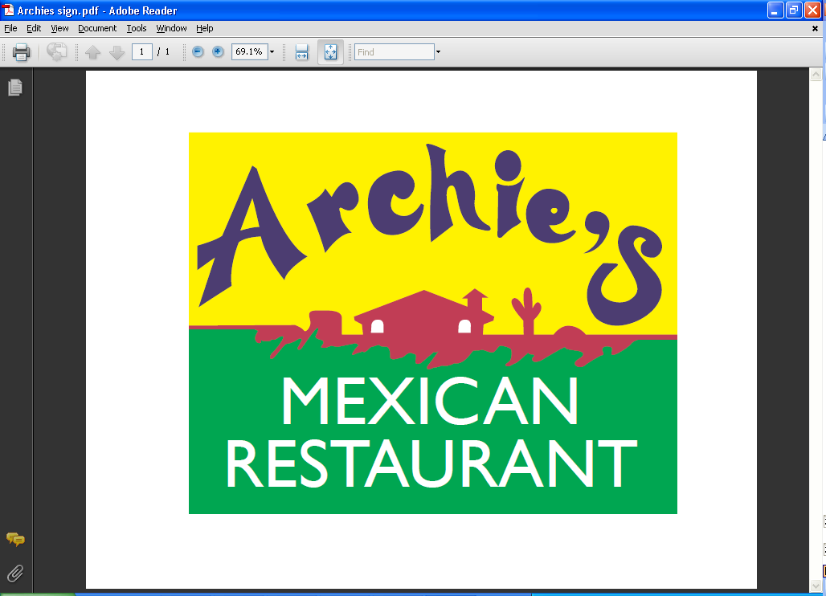
Restaurant Dining,
Banquet Room and Bar

17821 1st Avenue South,
Normandy Park, WA 98148

Orders to Go
(206) 436-0850

We use cholesterol free oil (except on refried beans).

Appetizers

Cheese Nachos Sm $6.00 Lg $8.00  Fresh, crispy chips with Cheddar cheese and garnished with tomatoes and green onions.  Beef Nachos Sm $7.75 Lg $9.25  Ground beef with Cheddar cheese, garnished  with tomatoes and green onions.  Chicken Nachos Sm $7.75 Lg $9.75  Shredded chicken with Cheddar cheese,  garnished with tomatoes and green onions.  Picadillo Nachos Sm $7.75 Lg $9.75  Shredded beef with Cheddar cheese, garnished with tomatoes and green onions.  Shrimp Nachos Sm $7.75 Lg $9.75  Baby Shrimp with Monterey Jack cheese garnished with tomatoes and green onions.  Cheese Crispy Lg $7.50  Deep-fried flour tortilla, covered with melted cheese.  Chicken Taquitos Lg $10.95  Deep-fried flour tortilla filled with chicken and cheese on a bed of lettuce and garnished with sour cream and guacamole.  *Camarones Mojo de Ajo $19.75  Prawns and mushrooms sautéed in a butter sauce with garlic and mild spices, garnished with avocado slices and tomatoes. | Super Nachos Sm $9.75 Lg $10.95  These house nachos come topped with beans, guacamole, sour cream, jalapenos, onion, tomatoes, Cheddar & Monterey Jack cheese.  With meat, add $1.25  Quesadilla Lg $10.25  Flour tortilla stuffed with melted cheese, tomatoes, onion and mild chilies. Served with sour cream and guacamole.  With meat, add $1.25  Fajita Quesadilla (Chicken or Beef) $12.50  Flour tortilla with your choice of meat, tomatoes, onion, green peppers and cheese. Topped with guacamole and sour cream.  Mexican Pizza Lg $11.25  Deep-fried flour tortilla topped with beans, beef, Monterey Jack cheese, tomatoes and onion. Garnished with sour cream and guacamole. With chicken, add $1.25  For Deluxe with sour cream and guacamole  add $3.00  Whole beans available as substitute for  refried beans.

Soup or Salad
Tortilla Soup $8.50  Hot and hearty chunks of tender chicken  breast and fresh avocado, with tortilla strips and shredded cheese in a rich chicken broth.  Dinner Salad $4.75  Lettuce, tomatoes, carrots and cheese. | Archie’s Salad $11.75  Char-broiled chicken with lettuce, tomatoes, carrots and cheese.  Taco Salad  Beef: $8.50 Chicken or Picadillo: $8.75  Tostada  Beef: $8.50 Chicken or Picadillo: $8.75

Beverages  Soft drinks (Coca-cola products) $2.75  Coke, Diet Coke, Sprite, Root Beer, Lemonade  Strawberry Lemonade $3.25  Hot or Iced Tea $2.75  Coffee $2.75  Hot Chocolate $2.75  Milk $2.75  Sangria  Wine  Chardonnay, Merlot and Cabernet  Margarita – Regular or Strawberry | Beers  Bottled American Beers: Budweiser, Bud Light, Coors Light, O’douls n/a.  Bottled Mexican Beers: Corona, Corona Light, Modelo Especial, Pacifico, Negra Modelo, Tecate, Corona Familiar.  Draft Beers: Please ask your server.

Traditional Mexican Dishes

Served with Spanish rice and refried beans.

Tacos al Carbon $17.25  Your choice of chicken or skirt steak grilled  with Pico de Gallo and corn tortillas. Topped with Parmesan cheese and guacamole.  Sopitos $13.00  Handmade corn masa shells topped with shredded beef, refried beans and lettuce.  Garnished with Parmesan cheese, guacamole and sour cream.  Fish Tacos $13.00  Three tacos made with soft flour tortilla and filled with Tilapia fish dipped in beer batter with cabbage and mayonnaise. Served with rice and beans. | Flautas $13.00  Crisp flour tortillas with your choice of chicken or shredded beef. Topped with Parmesan cheese, guacamole and sour cream.  Taquitos Rancheros $13.00  Crisp corn tortillas filled with your choice of chicken or shredded beef. Garnished with Parmesan cheese, guacamole and sour cream.  Pescado Frito $13.75  Pan-fried Tilapia fish topped with grilled onions. Served with rice, salad and tortillas.  Camarones Chipotle o a la Crema $18.50  Prawns sautéed with our Chipotle or cream sauce with carrots, mushrooms and onions. Served with rice, beans and tortillas.

.

Fajitas
All fajita dishes are served sizzling hot over a bed of
sautéed onions and green peppers.
Served with Spanish rice, refried beans, tortillas,
Pico de Gallo, sour cream and guacamole.

*Fajitas $17.75
With marinated steak, chicken or pork

*Fajitas de Camarones $19.25 *Seafood Fajitas $20.25
With prawns With prawns and Tilapia

House Specialties
Served with rice, refried beans and tortillas

Chef’s Special $19.25
Skirt steak with your choice of enchilada, tamale or chile relleno and guacamole.

Molcajete $17.50
A delicious bowl of chicken and top sirloin strips sautéed in a mild spicy sauce with onions, mushrooms and tomatoes. Topped with melted Monterey Jack cheese and slices of avocado.

*Archie’s Special $21.25
Your choice of a rib steak or carne asada cooked over charcoal. Accompanied by four prawns sautéed with mushrooms. Served with guacamole.

*Cielo, Mar y Tierra $23.25
Skirt steak and chicken cooked over charcoal, with bacon-wrapped prawns. Garnished with sautéed green pepper, onions and mushrooms. Served with rice and beans, guacamole and tortillas.

Mariscos – Seafood

*Cancun Platter $19.25
Prawns, crab, and chicken cooked with mushrooms, onions and tomatoes, topped with Monterey Jack cheese and guacamole.

*Camarones Mojo de Ajo $18.75
Prawns and mushrooms sautéed in a sauce of butter, garlic and mild spices. Served with rice, beans and tortillas.

*Camarones a La Diabla $18.75
Prawns sautéed with onions and mushrooms in a special spicy sauce. Served with rice, beans and tortillas.

*Arroz con Camarones $18.75
Prawns sautéed with mushrooms and crispy vegetables in a unique sauce. Served over a bed of rice with melted cheese and tortillas.

*Camarones Mexicanos $18.75
Prawns sautéed with vegetables in a spicy sauce. Served with rice, beans and tortillas.

Oven Baked Salmon $17.75
A lightly seasoned 8oz filet served with rice, Pico de Gallo and tortillas.

*Camarones Monterey $17.75
Prawns sautéed with butter, garlic and white wine with mushrooms, onions and green
peppers. Served on a bed of rice and broiled under a blanket of Monterey Jack cheese.
Accompanied by a side of tortillas.

*Camarones Apretalados $19.25
Bacon wrapped prawns served on a bed of onions, topped with Monterey Jack cheese. Served with rice, beans, sour cream, guacamole and tortillas.

Carne – Beef
Served with Spanish rice and refried beans.

Carne Asada $18.25
Flame-broiled skirt steak topped with onions. Served with guacamole.

Carnitas de Res $16.00
Top sirloin strips cooked with tomatoes, green peppers, onions and served with guacamole.

Steak Ranchero $16.95
Thinly sliced sirloin steak sautéed with onions, ripe tomatoes and fresh jalapenos in a rich tomato based sauce.

Chile Colorado $14.95
Tender cubed beef cooked in a tasty, simmered tomato sauce.

Steak a La Chicana $16.00
Top sirloin steak strips sautéed with green peppers and onions in our special Mexican sauce.

Steak Asado $18.25
Flame-broiled rib steak topped with onions. Served with guacamole.

Chile Verde $15.00
Chunks of tender pork cooked in a light tomatillo sauce with green peppers, onions and spices.

Pollo – Chicken
Served with Spanish rice and refried beans, except where noted.

Arroz Con Pollo $16.25
Boneless breast of chicken sautéed in a special sauce with mushrooms and onions. Served over a bed of rice and topped with Monterey Jack cheese. Not served with beans.

Pollo Chipotle $16.25
Chicken breast with our chipotle sauce and sautéed with fresh mushrooms and onions.

Pollo con Crema $16.25
Chicken breast cooked with green peppers, onions and sour cream.

Pollo Mexicana $16.25
Boneless chicken, green peppers and onions in a delicious, spicy sauce.

Pollo Asado $16.25
Grilled boneless chicken breast marinated with our own sauce.

Chicken Carnitas $16.25
Boneless breast of chicken cooked with green peppers, onions and tomatoes. Served with guacamole.

Chicken en Mole $16.25
Boneless chicken cooked in our sweet and spicy Mexican sauce.

Burritos

*Burrito Acapulco $18.50
Flour tortilla filled with prawns, scallops and crab with mushrooms, onions and green peppers. Topped with a special sauce, Monterey Jack cheese and avocado slices.

Fajita Burrito $14.50
Flour tortilla filled with your choice of steak, chicken or pork and rice and beans. Served with sour cream and guacamole With prawns: $15.50

Expresso Burrito $13.00
Flour tortilla filled with rice, beans and your choice of filling. Topped with guacamole, tomatoes, onions and Parmesan cheese.

Macho Burrito $13.00
Filled with chile relleno, rice and beans. Topped with lettuce, tomatoes, sour cream and Parmesan cheese.

Carne Asada Burrito $17.25
Flour tortilla filled with skirt steak, rice and beans. Served with sour cream, guacamole and Pico de Gallo.

Super Burrito $13.25
Flour tortilla filled with rice, beans, and your choice of filling. Topped with lettuce, tomatoes, sour cream and Parmesan cheese.

Burrito $12.50
Your choice of ground beef, chicken or Picadillo. Topped with melted cheese and sauce. Served with rice and beans.

Enchiladas

Enchiladas a La Crema $12.75
Two chicken enchiladas smothered with a blend of sour cream and Parmesan cheese with just a touch of spices.

Enchiladas Suiza $12.75
Soft corn tortillas filled with your choice of seasoned ground beef, chicken or Picadillo. Topped with our delicious tomatillo sauce and sour cream.

Enchiladas en Mole $12.75
Two soft corn tortillas filled with you choice of seasoned ground beef, chicken or Picadillo or cheese and onions, and topped with mole sauce and melted cheese.

*Enchiladas de Camarones $15.75
Two soft corn tortillas filled with baby shrimps, onions, tomatoes, rice and beans. Green sauce topped with Jack cheese, avocado slices and sour cream.

Enchiladas Chipotle $14.25
Three enchiladas with your choice of chicken, seasoned ground beef, Picadillo or cheese topped with our salsa chipotle and melted cheese.

Enchiladas $12.50
Two soft corn tortillas filled with your choice of seasoned ground beef, chicken, Picadillo or cheese and onions, then topped with our enchilada sauce and melted cheese.
One Enchilada $9.95

Vegetarian Plates

Enchiladas de Espinaca $14.50
Two corn tortillas stuffed with spinach, Jack cheese and topped with Pico de Gallo.

Vegetarian Burrito $13.75
Filled with whole beans, rice and vegetables, guacamole, cheese and sour cream. Topped with sauce and melted cheese.

Side Orders

Cheese, Beef, Chicken or Picadillo French Fries $2.75
Taco $2.25 Sour Cream $2.00
Enchilada $3.50 Guacamole $3.75
Burrito $6.25 Deluxe $3.00
Tamale $3.50 Rice $3.00
Chalupa $4.25 Beans $3.00
Chimichanga $6.75 Rice & Beans $4.25
Chile Relleno $4.00 Tortillas $1.75

Small Combination Plates
Choice of ground beef, chicken or Picadillo.
Served with Spanish rice and refried beans.

S1 – Chalupa - $10.00
S2 – Chile Relleno - $10.95
S3 – Chimichanga - $10.95

S4 – Enchilada & Taco - $10.95
S5 – Enchilada & Tamale - $10.95
S6 – Enchilada & Tostada - $10.95

Combination Dinners
Choice of ground beef, chicken or Picodillo.
Served with Spanish rice and refried beans (except #19)

#1 Two Chalupas - $12.50
#2 Two Chimichangas - $12.50
#3 Two Pork Burritos - $14.00
#4 Two Burritos - $14.00
#5 Burrito & Enchilada - $13.50
#6 Burrito & Chimichanga - $14.50
#7 Chimichanga Combo - $13.50 Choice of enchilada, chile relleno, or tamale
#8 Enchilada & Chalupa - $13.50
#9 Chalupa & Chile Relleno - $14.00
#10 Beef Burrito & Chile Relleno$13.50
#11 Enchilada & Chile Relleno - $13.50

#12 Two Chiles Rellenos - $12.75
#13 Chile Relleno & Tamale - $12.75
#14 Three Tacos - $13.50
#15 Three Enchiladas - $13.50
#16 One Taco & Two Enchiladas - $13.50
#17 Enchilada, Tamale & Taco - $14.00
#18 Enchilada, Tostada & Taco - $14.00
#19 Enchilada, Tostada & Chile Relleno $14.00
#20 *Huevos Rancheros - $10.95
#21 *Chorizo con Huevo - $11.75

Substitutions to Combination Menu add $1.25
Whole beans available instead of refried beans.
Add Deluxe (Sour Cream and Guacamole) for $3.00

American Plates

*Steak with French Fries $15.95 *Hamburger with French Fries $8.25
Grilled Cheese Sandwich $5.75 *Cheeseburger with French Fries $8.95

Desserts

Apple Chimichanga $4.95

Deep Fried Ice Cream $3.75
Churros $4.75

*Consuming raw or undercooked eggs, meats, poultry, shellfish or seafood may
increase your risk of food borne illness.

